Training, the process of taking a system that’s been
initialized with default or random values and gradually improving it so that it’s tuned to the data we want to
understand.
( https://www.youtube.com/watch?v=LZE-kyNszIU)
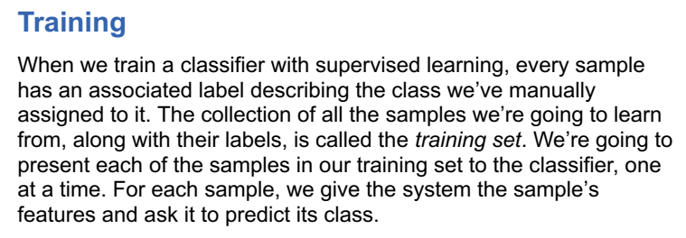
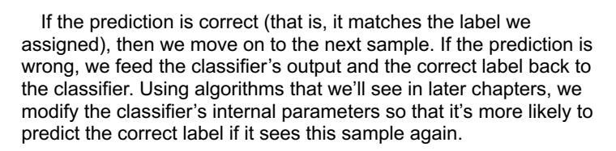
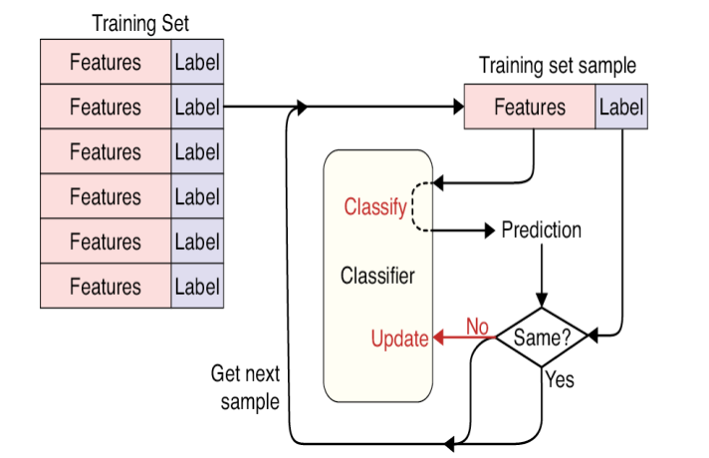
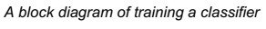
As our training process runs through this loop, one sample at a
time, the classifier’s internal variables are nudged toward values that
do an increasingly good job of predicting labels.
Each time we run through the entire training set, we say that we’ve trained for one epoch.
We usually run the system through many epochs so the system sees every sample many times.
Typically, we keep training as long as the system is still learning and improving its performance on the training data, but we might stop if we run out of time, or if we run into problems.
The training process works as follows
First, the weights of the network are initialized to small random values. Then the network performs a series of training steps.
At each training step, one batch of images is passed through the network and the errors are back propagated to update the weights.
The batch size determines how many images are in each training step batch.
The larger the batch size, the more stable the gradient calculation, but the slower each training step.
It would be far too time-consuming and computationally intensive to use the entire dataset to calculate the gradient at each training step, so generally a batch size between 32 and 256 is used.
It is also now recommended practice to increase the batch size as training
progresses.
This continues until all observations in the dataset have been seen once. This completes the first epoch.
The data is then passed through the network again in batches as
part of the second epoch.
This process repeats until the specified number of epochs has elapsed.
Training Deep Neural Nets
You may need to train a much deeper DNN, perhaps with (say) 10 layers, each containing hundreds of neurons, connected by hundreds of thousands of connections.
1. First, you would be faced with the tricky vanishing gradients problem (or the related exploding gradients problem) that affects deep neural networks and makes lower layers very hard to train.
2. Second, with such a large network, training would be extremely slow.
3. Third, a model with millions of parameters would severely risk over fitting the training set.
Back propagation algorithm works by going from the output layer to the
input layer, propagating the error gradient on the way. Once the algorithm has computed the gradient of the cost function with regards to each parameter in the network, it uses these gradients to update each parameter with a Gradient Descent step.
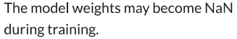
What is Vanishing Gradient Problem
The problem:
As more layers using certain activation functions are added to neural networks, the gradients of the loss function approaches zero, making the network hard to train.
Why:
Certain activation functions, like the sigmoid function, squishes a large input space into a small input space between 0 and 1. Therefore, a large change in the input of the sigmoid function will cause a small change in the output. Hence, the derivative becomes small.
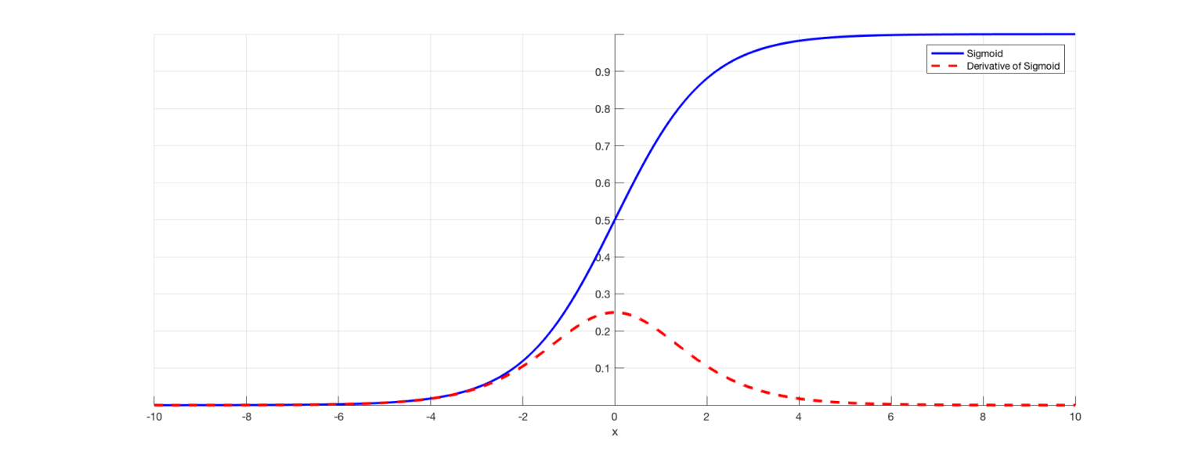
As an example, Image 1 is the sigmoid function and its derivative. Note how when the inputs of the sigmoid function becomes larger or smaller (when |x| becomes bigger), the derivative becomes close to zero.
Why it’s significant:
For shallow network with only a few layers that use these activations, this isn’t a big problem. However, when more layers are used, it can cause the gradient to be too small for training to work effectively.
However, when n hidden layers use activation like the sigmoid function, n small derivatives are multiplied together. Thus, the gradient decreases exponentially as we propagate down to the initial layers. A small gradient means that the weights and biases of the initial layers will not be updated effectively with each training session. Since these initial layers are often crucial to recognizing the core elements of the input data, it can lead to overall inaccuracy of the whole network.
Solutions:
The simplest solution is to use other activation functions, such as ReLU, which doesn’t cause a small derivative.
What Are Exploding Gradients?
An error gradient is the direction and magnitude calculated during the training of a neural network that is used to update the network weights in the right direction and by the right amount.

In deep networks or recurrent neural networks, error gradients can accumulate during an update and result in very large gradients. These in turn result in large updates to the network weights, and in turn, an unstable network.
What Is the Problem with Exploding Gradients?
In deep multilayer Perceptron networks, exploding gradients can result in an unstable network that at best cannot learn from the training data and at worst results in NaN weight values that can no longer be updated.verflow and result in NaN values.



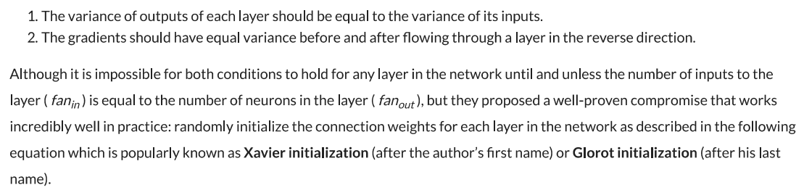
where n_{inputs} and n_{outputs} are the number of input and output connections for
the layer whose weights are being initialized (also called fan-in and fan-out). This initialization strategy is often called Xavier initialization (after the author’s first name), or sometimes Glorot initialization.
Using the Xavier initialization strategy can speed up training considerably, and it is one of the tricks that led to the current success of Deep Learning. The initialization strategy for the ReLU activation function (and its variants, including the ELU activation) is sometimes called He initialization.
Initialization parameters for each type of activation function
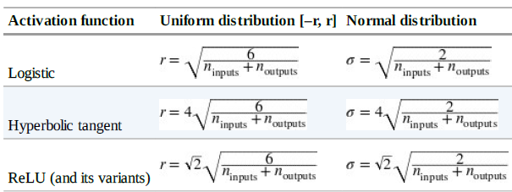

The vanishing/exploding gradients problems were in part due to a poor choice of activation function. Rather than sigmoid activation function, other activation functions behave much better in deep neural networks, in particular the ReLU (Rectified Linear Unit) activation function, mostly because it does not saturate for positive values. Unfortunately, the ReLU activation function is not perfect. It suffers from a problem known as the dying ReLUs: during training, some neurons effectively die, meaning they stop outputting anything other than 0. In some cases, you may find that half of your network’s neurons are dead, especially if you used a large learning rate. During training, if a neuron’s weights get updated such that the weighted sum of the neuron’s inputs is negative, it will start outputting 0.
To solve this problem, you may want to use a variant of the ReLU function, such as the leaky ReLU. This function is defined as LeakyReLUα(z) = max(αz, z) (Figure). The hyperparameter α defines how
much the function “leaks”: it is the slope of the function for z < 0, and is typically set to 0.01. This small slope ensures that leaky ReLUs never die; they can go into a long coma, but they have a chance to eventually wake up. Setting α = 0.2 (huge leak) seemed to result in better performance than α = 0.01 (small leak). They also evaluated the randomized leaky ReLU (RReLU), where α is picked randomly in a given range during training, and it is fixed to an average value during testing. Finally, they also evaluated the parametric leaky ReLU (PReLU), where α is authorized to be learned during training.
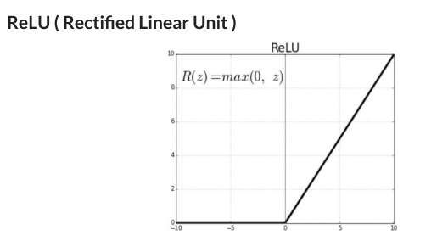
LReLU(LeakyReLU)
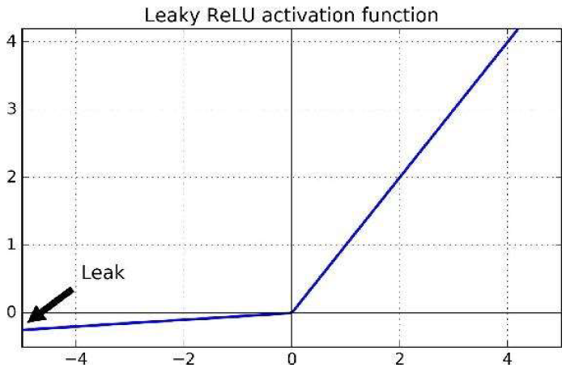
A new activation function called the exponential linear unit (ELU) that outperformed all the ReLU variants in their experiments: training time was reduced and the neural network performed better on the test set.
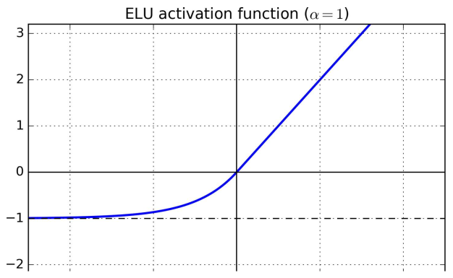
It looks a lot like the ReLU function, with a few major differences:
First it takes on negative values when z < 0, which allows the unit to have an average output closer to 0. This helps reduce the severity alleviate the vanishing gradients problem, as discussed earlier. The hyperparameter α defines the value that the ELU function approaches when z is a large negative number. It is usually set to 1, but you can tweak it like any other hyperparameter if you want.
Second, it has a nonzero gradient for z < 0, which avoids the dying units’ issue.
Third, the function is smooth everywhere, including around z = 0, which helps speed up Gradient Descent, since it does not bounce as much left and right of z = 0.
The main drawback of the ELU activation function is that it is slower to compute than the ReLU and its variants (due to the use of the exponential function), but during training this is compensated by the faster convergence rate. However, at test time an ELU network will be slower than a ReLU network.

